Technical Architecture Document
DM-XML

Approval
Name | Role  MOA/MOE | Date  Approval | Approval  Y/N | Address  DG or Company
Gianluigi Alari | e-Parliament program manager |  |  | ITEC
Olivier Fabbri | Project Manager |  |  | ITEC
CIRCULATION
Name -Telephone number |  | DG or Company | ERICA code
Olivier Leboeuf (OLE) |  | ITEC | C
Claudio Fabiani (CFA) |  | ITEC | C
Felicity Hands (FHA) |  | TRAD | C
Gianluigi Alari (GAL) |  | ITEC | C
Jesus Cerro (JCE) |  | ITEC | C
Olivier Fabbri (OFA) |  | ITEC | R
Bogdan Boranda (BBO) |  | ITEC | R
Nikitas Tsopelas (NTS) |  | ED | IA
Manolis Pitarokoilis (MPI) |  | ED | IA
Marianna Dikaiakou (MDI) |  | ED | IC
Charalampos Tripodianos (CTR) |  | ED | ICA
Updates
Version | Date | Sections changed | Description | Author(s)
1.0 | 07/07/2011 | all | document creation | OFA
1.1 | 22/10/2012 | all | use of last PMM4EP template, update with oracle version | OFA
1.2 | 5/12/2012 | all | added proposed technologies | MDI
1.3 | 9/12/12 | all | review | BBO, JCE
1.4 | 15/12/12 | all | review | BBO,JCE
1.5 | 21/12/12 | all | adding ALSA comments | BBO,JCE
1.6 | 14/01/2013 | all | Updated document with accepted technologies and requested diagrams | MDI
Table of content
1. General Introduction 4
1.1. Purpose 4
1.2. Usage conventions 4
1.3. Applicable and Reference Documents 4
1.4. Glossary 4
1.5. Procedure 'Technical Architecture' 5
2. Architecture - Description 6
2.1. Basic information 6
2.2. Network Architecture Schema 6
2.3. Software Architecture 7
2.4. Required Standard Runtimes 7
2.5. Non-standard server-side softwares list 8
2.6. Integration 8
2.7. Security 10
3. Specific Development Tools 11
4. ANNEXE I 12

General Introduction

Purpose
This document contains a description of the DM-XML project for submission to the IT correspondent of the DIT for its opinion on the technological/technical assumptions on which it is based. It is essential for this opinion to be sought in order to ensure that the elements on which the project's success will depend (methods, architectures, tools, components, etc.) are valid and authorised within the EP.

Usage conventions
The parts in yellow indicate the area where information should be entered, and must remain in yellow to highlight information connected with the project.
Where a chapter or section is not considered to be applicable, put ‘NOT APPLICABLE’.
Click on the Show/Hide button in the toolbar to display/hide guidance on filling in this document.
Guidance displayed.

Applicable and Reference Documents
This chapter sets out the reference documents on which this guide is based.

Applicable Documents
This section details the applicable documents used in drafting this document. The applicable documents are standards, specimen plans which need to be applied and whose application is verifiable.
N° | Title | Remarks
[1] | DM-XML_CHP_EN_v21.doc | Project Charter
[2] | DM-XML_DEB_EN_v21.doc | Needs study
[3]

Reference Documents
This section details the reference documents used in drafting this document. Reference documents help in defining the project but are not directly applicable (e.g. software reference manuals, sample files from outside firms, meeting papers).
N° | Title | Remarks
[1]
[2]
[3]

Glossary
The glossary is available at ICTASnet : - Zone 'Vos indispensables'-Glossaire.
Abbreviation | Description
DTA | Technical Architecture Document
RHR | Runtime Hosting Request

Procedure 'Technical Architecture'

Sending a Technical Architecture Document (DTA)
The DTA and/or RHR(s) documents have to be sent to the IT correspondent of the DIT.

Validation of the DTA
As soon as the DTA is completely validated then the DTA is sent to ITO to continue the treatment along with one or multiple Runtime Hosting Requests (RHR).

ICTAS support
During the project, ICTAS can support the team project (MOA+MOE) but on request only.
ICTAS provides relevant information (standard, methods) in the Quality Assurance Manual and the appropriate documents (templates) for the project.

ITO support
ITO deals with the DTA as soon as it is validated by ICTAS.
ITO initiates a meeting with the stakeholders of the project in order to organise the technological environments necessary for the project.
For more information see ITO Website.

Architecture - Description

Basic information
This chapter describes the deliverables (applications, components, integration component) of the product in the EP's network using a synthetic schema.
Intranet | Y
DMZ | N
VLAN dedicated | N
Internet access through the EP portal | N
Other | N

Network Architecture Schema
DM-XML is the application that performs all the transformations and pre-translations of XML data for the text production in the frame of the e-Parliament program. All the applications that will need to use the DM-XML services will have to access it via its API (Java binding or Web Services binding). All the services offered by DM-XML are stateless. The figure below depicts how the DM-XML services make use of other services (CODICT, PURE-XML, ITER) and provides its services to its clients (CAT4TRAD, DST, AT4AM).
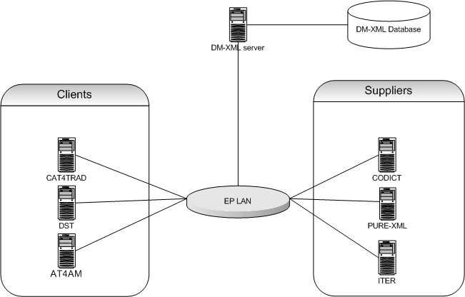
Figure 1: Network architecture diagram

The network topology complies to the regular J2EE Intranet network architecture:
  - DM-XML Web application is hosted on an in-house J2EE server (Tomcat) and accessed in the Intranet via HTTP protocol
  - Authentication will not be implemented
  - Role-based authorisation will be implemented, based on group membership
  - The persistence layer is assured by in-house Oracle databases
Insert a synthetic schema representing general software components in their respective network zones (application servers, applications, products...etc), as well as their interactions and the protocols used for these interactions.

The DM-XML application is composed of the following components:

Software Architecture
This chapter describes the software architecture according to the following schema:
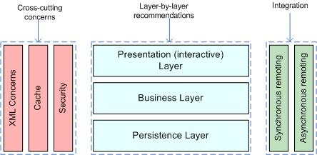
List the technologies/libraries used.
Client User interface | N
Server Presentation layer | N
Server Business layer | Spring 3.1.3 (latest production release)
Server Persistence Layer | Spring Data 1.1/JPA / HIBERNATE 4.1.7
RDB | Oracle 10gR2
Synchronous Remoting (WS, RMI...) | Spring MVC 3.1.x for RESTful Web Services
Asynchronous Remoting (JMS...) | N
XML Handling | JAXP / StAX / TrAX
Cache | Ehcache 2.6.2
Security | Authentication not implemented in the current scope. Role-based authorisation will be implemented, with custom Spring-based declarative authorization.
XSLT Processor | Saxon-HE 9.3
XSLT 2.0 | Saxon-HE 9.3
Other | Jackson 1.9.11 (latest official release)

Document generation: Aspose.Word for JAVA

Required Standard Runtimes
This chapter lists the various required server-side softwares (for example, Tomcat, HornetQ...etc), and their runtime codes (allowing to map this document with multiple Runtime Hosting Request(RHR).
List of required operational environment and associated 8 characters Code:
Existing  (Y/N) | Standard Runtime | Code  (8 char) | Environment(s)  DEV, PPO, FOR, PROD, INT
N | Tomcat 6.0.18, Java 1.6.0_31 | DMXMLDV | DEV
N | Tomcat 6.0.18, Java 1.6.0_31 | DMXMLIT | INT
N | Tomcat 6.0.18, Java 1.6.0_31 | DMXMLPP | PPO
N | Tomcat 6.0.18, Java 1.6.0_31 | DMXMLPR | PROD
Please note that one separate RHR document will be needed for each new runtime.

Non-standard server-side softwares list
This chapter lists the various required non-standard server-side softwares.
Please note that these non-standard pieces of software are most likely not to be accepted quickly, though may trigger special attention and dedicated handling.
Fill in this chapter as accurately as possible.

Non-Standard Server-side software | Explanation of the need
Saxon-HE 9.3 | Saxon supports XSLT 2.0, unlike Xalan that only supports XSLT 1.0. Furthermore, the compiled version of Saxon with the TinyTree object model has very good results in performance benchmarks.
Jackson 1.9.11 | JSON string manipulation needed to generate the Aspose input. Jackson is the richest and most widely used JSON library in Java.

Integration
This chapter describes integration of the product with other applications or services (Database, directory, etc.) and contracts and protocols used.

Applications integration schema

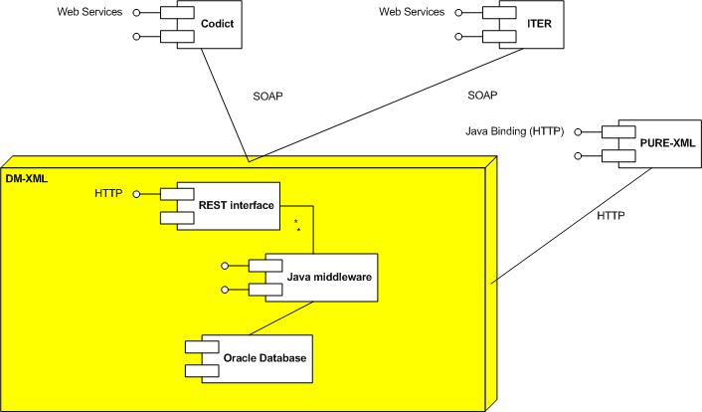
Figure 2: Applications integration schema

This section has to contain a schema describing interactions between applications. You have to precise the protocols used, and information needed to describe the exchanges (synchronous (remoting, web services), asynchronous (JMS, etc.).
Several e-Parliament projects will call DM-XML stateless services:
- AT4AM
- DST
- CAT4TRAD

DM-XML will consult some applications using stateless services:
- CODICT (CSC)
- ITER-WS

Application integration criticality
Reference | Protocol | Synchronicity | Frequency | Business Criticality
PURE-XML | HTTP | Synchronous | >1000/min | High
CODICT | WS | Synchronous | >1000/min | High
ITER-WS | WS | Synchronous | < 10/min | Med

If the application cannot contact PURE-XML, some resources requested by the web service clients will not be accessible.

If CODICT services layer is not available, the results of some services will be poor.
Without ITER-WS, the init service of DM-XML will not be able to get the title of the document.

System

List of required system services
Database | Oracle 10.2.0.5
File system (direct access, sharing, FTP, ...) | Direct access
Directory (Active Directory, other) | N
Mails (Sending mails from an application) | N
Application Server | EP Tomcat 6.0.18
JDBC | Oracle OCI driver 10.2.0.3.0
Other | N

System services schema (optional)
For clarity (and mostly if you have asked for multiple runtimes), please provide a schematic vision of the interaction between system services and applications.

Security
This chapter describes the needs for security (secure client access, integration, confidentiality (signature) data exchanged or stored, business services implemented, etc.).

Authentication mechanism

DM-XML will be a service layer which will expose only WebServices. No authentication will be implemented. The services will trust the calling applications. Each webservice invocation will receive the user which was already authenticated by the calling application.

Authorization mechanism
The internal access control module is based on group membership of the already authenticated user by the calling application.
DM-XML will keep a record of calling applications and the services they are permitted to access respectively.

Specific confidentiality needs
None

Specific Development Tools
The purpose is to mention only components which need a special or specific attention
The ICTAS Unit provides standard tools for the development of applications.
Mention here licence-limited tools you may need (restricted use product):

Oxygen XML | Y
Modelling tool UML | Y

Non standard tools and justification:

ANNEXE I
EXAMPLE 1:

In XSLT2, it is possible to declare function inside the XSLT. That feature will simplify and rationalize the xslt coding.
For example the specific EP formatting can be centralised in functions:

<xsl:function name="a:CreateDocketNumber">
<xsl:param name="year"/>
<xsl:param name="num"/>
<xsl:param name="code"/>
<xsl:value-of select="$year"/>/<xsl:value-of select="$num"/>(<xsl:value-of select="$code"/>)
</xsl:function>
called by :

<xsl:value-of select="a:CreateDocketNumber('2012','9999','INI')"/>

that will produce :

2012/9999(INI)

EXAMPLE 2:

Dates are of course present in the XML document and instead of developing a date formatter in xslt, the format-date function already exists in XSLT2 :
<xsl:value-of select="format-date(current-date(),'[FNn], [D1o] [MNn,*-3], [Y]','en',(),(),)" />
that will return :
Wednesday, 4th May, 2011

EXAMPLE 4:

Using the analyze-string feature with regex parameter will simplify the post-treatment phase in WS2 (initiate document)

For example, to put the right attribute required by Akomantoso for docNumber

<xsl:template match="//a:docNumber">
<xsl:analyze-string select="." regex="COM(\d{{4}})\d{{4}}">
<xsl:matching-substring>
<!-- put attribute ep:ref="xml4ep:/doc/idSchema/COMNumber" -->
</xsl:matching-substring>
<xsl:non-matching-substring>
<!-- put attribute ep:ref="xml4ep:/doc/idSchema/SessionNumber" -->
</xsl:non-matching-substring>
</xsl:analyze-string>
</xsl:template>

E: Examination, R: Responsible, I: Information, C: Contribution, A: Approval
DM-XML requires XSLT 2.0 to facilitate the implementation of different functionalities. See some examples in annexe I.
Runtime: for example: Tomcat, HornetQ.etc
Environment (DEV, PPO, FOR, PROD, INT...etc)
An identifier helping to point this relation in the Application Integration Schema
Frequency of the interaction (e.g. once every night for a batch, thousands of calls per minute if directly related to end user input or interaction)

